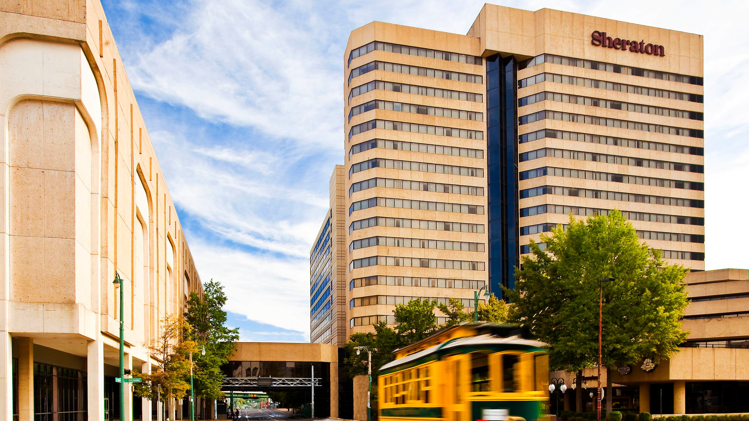
Tennessee Chapter
International Public Management Association for Human Resources

26th Annual TPMA Membership and
Training Conference
April 24th – 26th, 2019
Sheraton Memphis Downtown
Memphis, Tennessee

Exhibitor Prospectus



An Invitation to Exhibit/Sponsor/Advertise

Tennessee Chapter of the IPMA-HR
26th Annual Membership and Training Conference

April 24th – 26th, 2019

Sheraton Memphis Downtown Hotel

Memphis, TN

You are cordially invited to exhibit/sponsor/ advertise at the Tennessee Chapter of the International Public Management Association for Human Resources Annual Training and Membership Conference being held April 24-26, 2019.
Sheraton Memphis Downtown Hotel
250 N. Main Street
Memphis, TN 38103

About TPMA

TPMA is known as the “Tennessee Personnel Management Association” and is the official Tennessee Chapter of the International Public Management Association for Human Resources (IPMA-HR).

Chapter Objectives

1. To provide a forum for persons engaged in public personnel administration to discuss their current problems and to provide a medium for their mutual self-improvement;
2. To implement the objectives and programs of the International Public Management Association for Human Resources within the chapter area;
3. To explain and interpret the objectives and methods of personnel administration to the general public, civic groups, government officials and employees;
4. To encourage and facilitate cooperative action among public jurisdictions and private employees within the chapter area on personnel problems of mutual concern; and
5. To provide educational opportunities for the membership to further the objectives of the Chapter in the form of conferences, seminars and regional meetings.

2019 TPMA Annual Membership and Training Conference

The Tennessee Personnel Management Association Annual Membership and Training Conference is part of TPMA’s overall mission to provide a forum for HR professionals to discuss current issues and provide educational opportunities to the membership. About a hundred personnel professionals from across the state of Tennessee will be coming to Cool Springs to participate in this educational program, work sessions, and recreational activities. Attendees will represent a unique cross-section of personnel professionals from the public sector. These are the people who make personnel decisions for their organization and agencies including HR Directors, City Recorders and City Managers. We have arranged the conference program to allow attendees considerable interaction with the exhibitors. The breaks and continental breakfast area will be located in the exhibit space.

Who Should Exhibit?

You will reach a receptive audience of public sector HR professionals (representing local, state and federal levels of government) if you manufacture, represent, distribute, or sell products/services in the following categories:
Assessment Tools and Training (Police, Fire, Administrative Support) ● Automated Performance Appraisal Systems ● Broad-banding and Pay for Performance ● Classroom Resource ● Compensation ● Benefits ● Learning and Development Seminars Software ● Computer Software ● Electronic Salary Survey Services ● Employee Health Promotion and Wellness ● Employee Recognition ● Employee Surveys ● Examination and Recruitment Planning ● FMLA, FEHA, VAWA, ADA Information ● Government Agencies ● HR and Payroll computer Systems ● HRMS ● Insurance Brokers ● Class and Comp Consultants ● Motivational Material ● Online Applicant Testing Services ● Online Recruitment Systems ● Performance Management Programs ● Publishers ● Recruitment ● Risk Management ● Safety Products ● Salary Data and Software ● Selection Testing ● Software Applications & Test Rental Vendors ● Standardized Test Products ● Stress Relievers ● Training & Technical Assistance ● Training Videos/DVDs on HR Topics ● Workforce Planning Tools ●

PLUS, YOUR PRODUCT OR SERVICE!

A Sampling of Current/Prior
Exhibitors & Sponsors
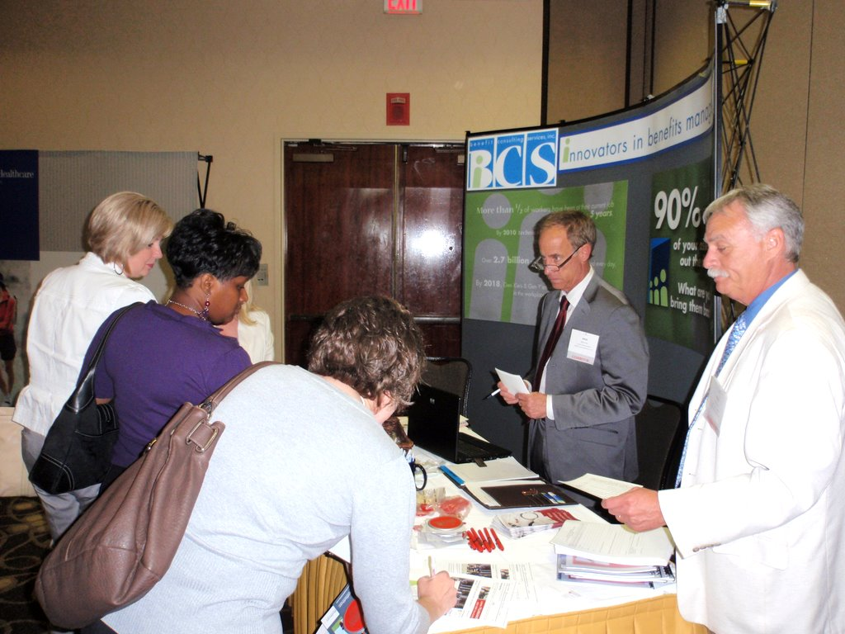
ABC Computer Learning, ADP Services, Aegis Analytical Laboratory, Aetna/ING Financial Services, AFLAC, Ameritas Group Dental & Eye Care, Benefit Consulting Alliance, AON Consulting, Assurant Employee Benefits (formerly, Fortis), Benefit Consulting Services, Inc, Benefit Solutions, BEST (Baccalaureate Education System Trust), BlueCross BlueShield of Tennessee, Bluegrass Family Health, Brentwood Services, Inc., Bryan, Pendleton, Swats & McAllister, LLC, Bryan Pendleton Swats & McAllister LLC, Burris & Associates, The Business Source, Center for Non-profit Management, The Centre Group, Century II Staffing, CIGNA HealthCare, CMS Uniforms, Collins & Company, Colonial Supplemental Insurance, Concentra Medical Centers, Consociate Group, Cornerstone of Recovery Inc., Corporate Systems Administration, Inc., CorVel Corporation, Counsel on Call, Crichton Brandon Jackson and Ward, Critical Access, Inc., Crye-Leike, Inc., CVS Caremark, David M Griffith & Associates, Ltd, Dental Solutions+, EnterChange, ESGR, (Employer Support for the Reserves and National Guard), Forrest & Forrest Benefits, Inc, Gordian Health Solutions, The Hartford, Health Consultants, HealthSpring Insurance, HealthSTAT, Inc., Heritage National Healthplan, The HR Group, Huber & Lamb Appraisal Group, Inc., ICMA Retirement Corporation, Info-Mation Services Corporation, Intracore, Iron Age Corporation, J. C. Bradford and Company, John Deere HealthCare, Kroll BGA, Liberty Mutual, LifeServices EAP, Lifesigns, Lincoln Financial Group, Local Government Data Processing, Local Government Employee Benefits, Inc, M. Lee Smith Publication, MAXIMUS, Inc., Mercer Human Resource Consulting, Nashville State Community College, Olsten Staffing Services, National Safety Alliance, Nationwide Retirement Solutions, NEOGOV, Inc., New Horizons, PENCIL Foundation, Principal Financial Group, Public Employees Benefits Services Corporation (PEBSCO), Randstad Staffing, Resource Associates, RESULTS Physiotherapy Centers, Shaun M. Callahan, Southeast Financial Federal Credit Union, The Standard, Strayer University, Thomas & Thorngren, TIAA-CREF, TML Risk Management Pool, TN Board of Regents Online Degree Program, Tennessee Foreign Language Institute, Trauger & Tuke, TSU - Center for Extended Education, United Health Care, Unitog Rental Services, UT/Alcohol & Drug, Recovery Center, W. E. Shaw & Associates, Webster University Worldwide, WellPoint, Inc. (Health Management Corporation), Wells Fargo Company Zycron IT Staffing and Outsourcing.
General Information

Conference Date:
April 24-26, 2019

Expo Date:
April 24-25, 2018

Location:
Sheraton Memphis Downtown
250 N. Main Street
Memphis, TN 38103

Reservations:
(901)527-7300

Rate:
$139.00 Single/Double Rate

Exhibit Size:
Tabletop exhibits
(Includes electricity upon request)

2019 Exhibit Fee Structure
(The exhibit fee will include one complimentary conference registration and one complimentary booth personnel registration. Additional attendees may register at the non-members rate)

Cost per Exhibit Space $400 before March 15th, 2019
$450 between March 15th and April 1st, 2019
$500 after April 1st, 2019

2019 Exhibit Schedule & Sponsorship Opportunities
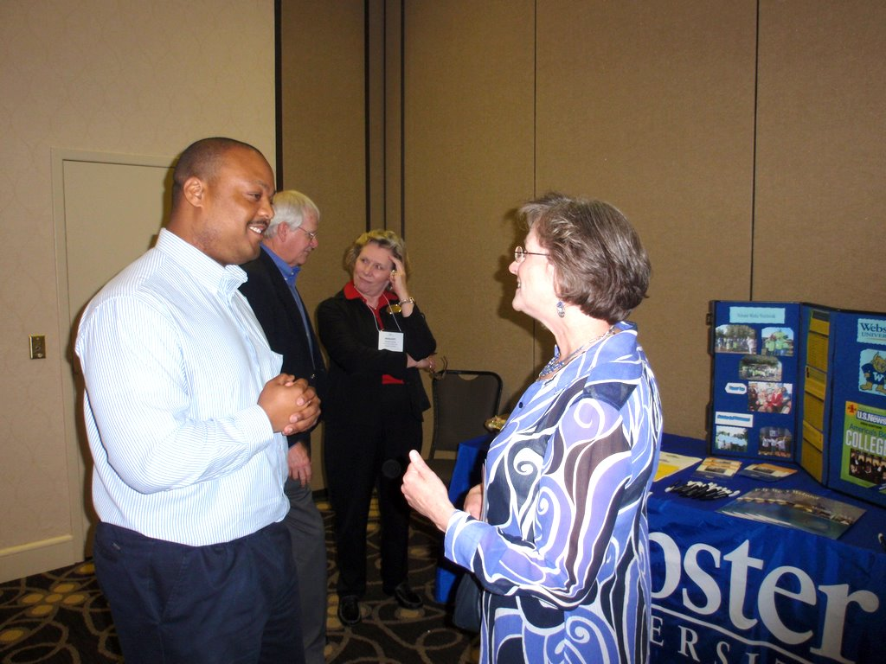
Tuesday, April 23th (7:30am – 4:30pm)
7:30am – 8:00am Hosted Pre-Conference
Continental Breakfast
10:00am – 10:30am Hosted Pre-conference
Mid-morning Break
12:00noon – 1:00pm Hosted Pre-Conference
Luncheon
2:00pm – 2:30pm Hosted Pre-Conference Break
Wednesday, April 24th (7:30am – 4:30pm)
7:30am – 8:00am Hosted Pre-Conference
Continental Breakfast
10:00am – 10:30am Hosted Pre-conference
Mid-morning Break
10:00am – 12:00noon (Exhibitors Move-in)
12:00noon – 1:00pm Hosted Pre-Conference
Luncheon
2:00pm – 2:30pm Hosted Conference Afternoon Break
6:30pm – 7:30pm Hosted Reception
Thursday, April 25th (8:00am – 2:30pm)
8:00am – 8:30am Hosted Conference Continental Breakfast
10:00am – 10:30am Hosted Conference Mid-Morning Break
11:30am – 1:30pm Hosted Conference Luncheon
2:30pm – 3:00pm Hosted Conference Afternoon Break
3:00pm (Exhibitors Dismantle)
Friday, April 26th (8:30am – 11:00am)
8:30am – 9:30am Hosted Full Breakfast Buffet

Staffing of exhibits is optional during general sessions. Continental breakfast and refreshment breaks will be held each day in the Exhibit area to generate traffic. Door prize drawings will be held after each session of the conference and during the Thursday, April 26th, afternoon break. You are invited to draw for any special prizes you may bring at anytime during the conference.
The following are included with each exhibit space

- Tabletop table with two chairs, electricity and wastebasket
- One Complimentary full conference registration (includes all meals and social activities)
- Opportunity to purchase additional conference registrations at the regular member rate for additional staff persons.
- One Complimentary booth personnel registration (does not include meals or social activities)
- Complimentary listing in the conference App
- List of conference attendees after the conference.

The following are not included with your exhibit space

- Decorations Water
- Internet connection Guard service
- Labor Gas

Additional services are available through the hotel service manager (appropriate charges may apply).

We expect to sell out the exhibit area very quickly, so don't delay. Complete the attached exhibitor application and mail it with your payment today or use the on-line registration to pay by credit card. Booth space will be assigned according to the date of receipt of exhibit application and required payments.
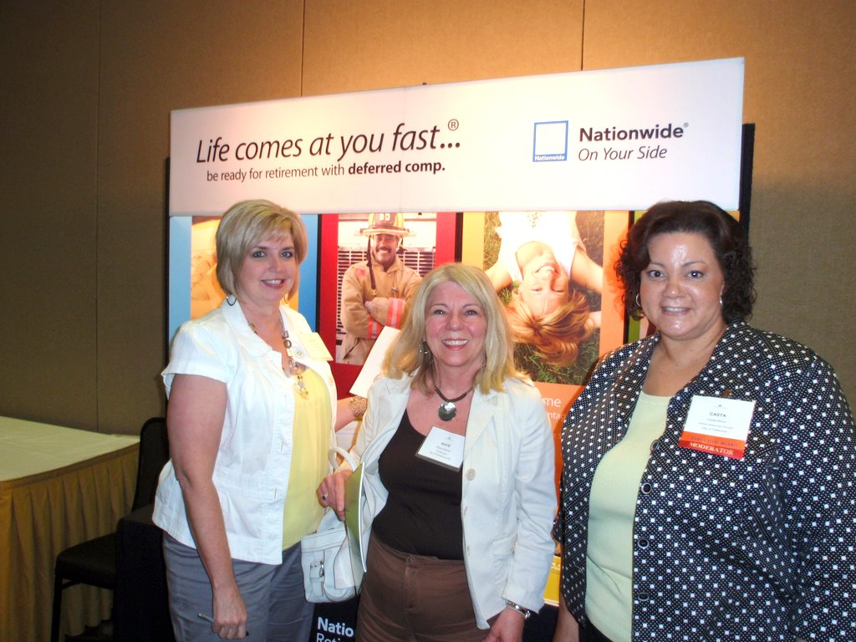
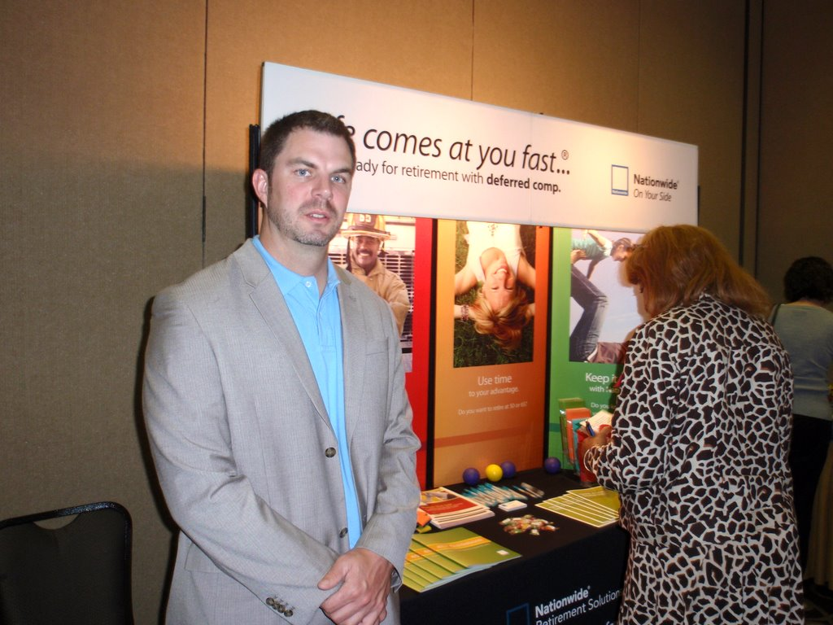

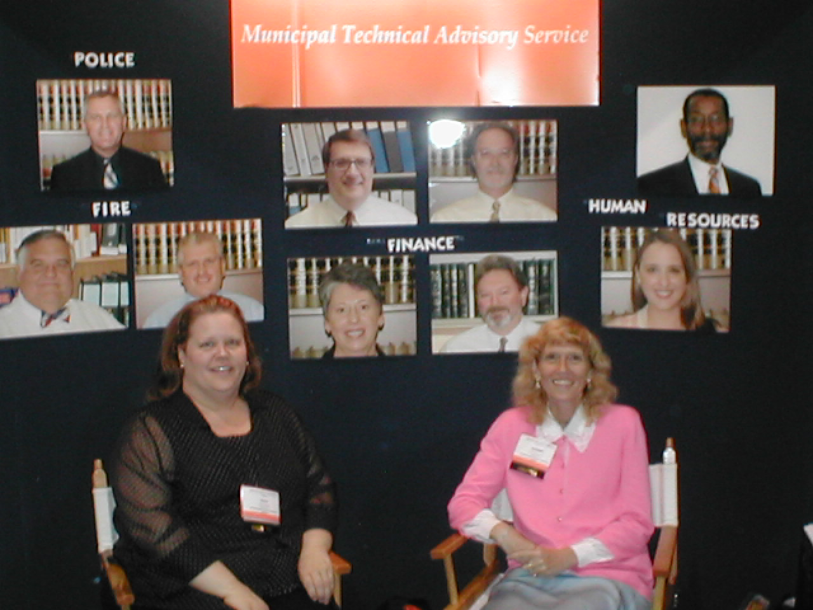
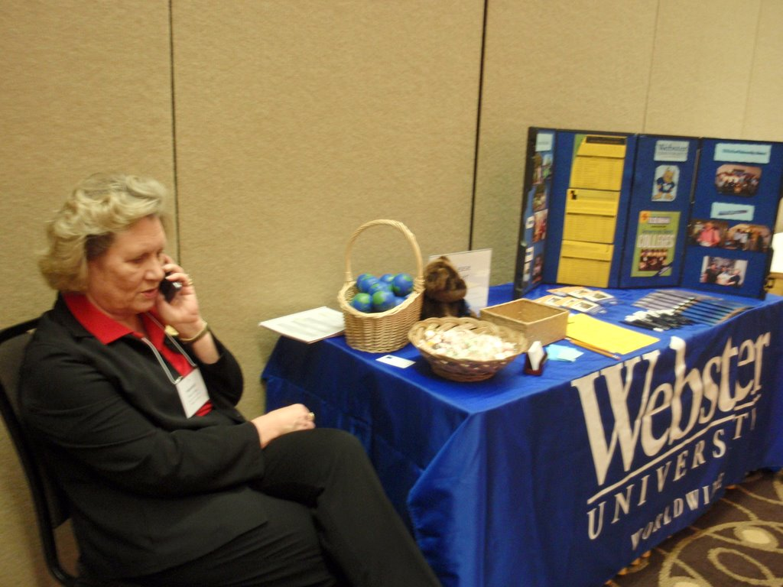

If you have questions, please contact Steve Wilensky, Exhibitor/Sponsor Chair at (901) 757-7274 or Richard Stokes, Executive Director at (615)532-4956.

2019 Sponsorship Opportunities
Does the opportunity to promote your business among HR professionals from across the state fit in with your marketing objectives? Sponsorship at the conference will elevate your organization’s presence at this important local government HR event. Sponsorship opportunities are available on a first-come, first-served basis.

Platinum Level Partner

ALL SPONSORS RECEIVE THE FOLLOWING BENEFIT PACKAGE:
- Repeat exposure to nearly 100 attendees
- Free “Take-One” literature display
Past President’s Luncheon $3,000
Platinum Level Partners Receive:
- Complimentary full conference registration (includes tickets to all social activities)
- A promotional insert in the conference tote bag (limited to a single item not to exceed 81/2” x 11”)
- Complimentary exhibit space
- Conference registration list
Thursday, April 25th, 2019
The Past President’s Luncheon is the first full non-seminar activity involving all participants. Recognition includes the opportunity to address the attendees.

TPMA Social Events $3,000
Thursday, April 25th, 2019
This year’s TPMA Social Event will provide attendees the opportunity to choose their activity. Sponsor both events. Recognition includes the opportunity to address the attendees.

Gold Level Partners Receive:
- Complimentary full conference registration (includes tickets to all social activities)
- A promotional insert in the conference tote bag (limited to a single item not to exceed 81/2” x 11”)
- Complimentary listing in the conference app
Full Breakfast $1,500
Friday, April 26th, 2019
The culmination of the conference begins with a fully plated breakfast.

Gold Level Partner
Hospitality Suite $1,500
Hospitality
Wednesday, April 24th, 2019
Take this opportunity to formally host participants during their evening down time.
Conference Program, Lanyard
& name badges $1,500
Jim Dillard Golf Tournament $1,500
Tuesday, April 23th, 2019
12:00pm – 4:00pm

Silver Level Partner
Silver Level Partners Receive:
- A promotional insert in the conference tote bag (limited to a single item not to exceed 81/2” x 11”)
- Complimentary listing in conference app
Networking Breaks $900 each
Wednesday and Thursday (24th & 25^{th,} 2019)
Refreshment areas in the exhibit area are highly visible centers of activity during session breaks. Place your promotional material around the area or provide company-branded napkins. Signs will announce your organization’s sponsorship of the networking break.
April 24th, 2019 2:00pm – 2:30pm
April 25th, 2019 10:00am – 10:30am
April 25th, 2019 2:00pm – 2:30pm

Conference Tote Bags $900
Distributed at registration, your logo will be carried throughout the event and into the future.

Travel/Zip Drive $750

Bronze Level Partner
Bronze Level Partners Receive:
- Your brand imprinted on each item.
- Conference listing in conference app
Zip Drives will be placed in every conference tote bag. The Drive will provide attendees with computer access to speaker presentations but will be used countless times storing and retrieving data.

Pre-Conference Activities (The 3 Pillars of HR Certificate Program)

The pre-conference session is attended by many young professionals seeking additional training opportunities through TPMA. Have your company’s name and brand recognized for your support of continued HR development. Expected attendance is from 20 – 30 participants.

Tuesday, April 23rd 7:30am – 8:00am Pre-Conference Continental Breakfast $750
Tuesday, April 23rd 12:00noon – 1:00pm Pre-Conference Luncheon $750
Wednesday, April 24th 7:30am – 8:00am Pre-Conference Continental Breakfast $750
Wednesday, April 24th 12:00noon – 1:00pm Pre-Conference Luncheon $750

Honorable Mention
Tuesday, April 23rd 10:00am – 10:30am Pre-conference Mid-Morning Break $375
Tuesday, April 23rd 2:00pm – 2:30pm Pre-Conference Afternoon Break $375
Wednesday, April 24th 10:00am –10:30am Pre-conference Mid-Morning Break $375

Application and Contract
For Exhibit Space/Sponsorship

The undersigned hereby applies for space at the TN Chapter of IPMA-HR Membership and Training Conference to be held in Memphis, TN, April 23-26, 2019 at the Sheraton Memphis Downtown Hotel and agree that if accepted will be bound by the conditions, rules and requirements specified herein.

PLEASE COMPLETE APPLICATION FORM BELOW AND RETURN TO:
TPMA
P.O. Box 190485
Nashville, TN 37219-9998
Check all that apply: Exhibit Sponsor
Company Name: ___________________________________________________________
(as it should appear in registration material)
Company Address: ___________________________________________________________

City: _____________________________ State: ______ Zip: _________________________

Telephone: __________________________ Fax Number: __________________________

E-mail: _________________________________ Website: ________________________________

Submitted by: _______________________________________________________________

Signature: __________________________________________________________________

A. EXHIBIT SPACE ______# of booths X $__________ = $___________ total
(Below pricing is for first booth. Additional booth(s) at $200 each)

On or before March 15, 2019 ____ $400 Additional Booth ____ $200
Between March 15th and April 1st ____ $450
After April 1, 2019 ____ $500 Additional Registrant ____ $175
($250 after April 1, 2019)
(Complete Section D) Jim Dillard Golf _____$50
Complimentary Registrant ____ $ 0 Tournament

Will you need electricity? Yes No
PRODUCT/SERVICE DESCRIPTION

B. SPONSORSHIP (Indicate one preferred event below at the desired sponsorship level)
Assignment of sponsorships for a particular event/item is on a first-come, first-served basis.

Platinum $3,000  Past President’s Luncheon  Social Event  (Complete Section D & E) | Gold $1,500  Full Breakfast  Hospitality Suite  Jim Dillard Golf Tournament  (Complete Section D) | Silver $900  Networking Break  Conference Bag | Bronze $750  Travel/Zip Drive  Pre-Conference Breakfast  Pre-Conference Luncheon | Honorable Mention 375  Pre-Conference Break: Mid-Morning  Pre-Conference Break: Afternoon
C. COMPLIMENTARY REGISTRANTS: (includes all meals and social activities)

Name | Address  (if different from above) | City  (if different from above) | State | Telephone Number  (if different from above)

D. COMPLIMENTARY STAFF REGISTRATION: (includes no meals or social activities)
Name | Address  (if different from above) | City  (if different from above) | State | Telephone Number  (if different from above)

E. Other Company Representative @ $175.00: (includes all meals and social activities)

Name | Address  (if different from above) | City  (if different from above) | State | Telephone Number  (if different from above)

F. EXHIBITING TERMS

1. Assignment of space shall be determined according to earliest post marks.
2. Assignment of space shall be made by the conference exhibit coordinator and considered accepted, unless rejected in writing within ten days of notification of space assigned.
3. Additional registrations are available at the regular conference rate of $175.00.
4. All space reservations will be made on a first come, first-served basis. Cancellation prior to March 15th, 2019 will be honored with a full refund. 50% refunds will be made if cancelled between March 15th, 2019 and April 1, 2019. No refund will be issued after April 1, 2019.

G. PAYMENT INFORMATION

Payment in full should accompany this agreement or arrangements should be made with either the Exhibit/Sponsorship Chairperson or the TPMA Executive Director.

Total Amount Enclosed: _________________________________________________
Method of Payment: (Check One)
Please Bill us Check payable to TPMA Credit Card (on-line only)*
Make Check payable to:
TPMA
P.O. Box 190485
Nashville, TN 37219-9998

* Credit Card can only be used by completing the exhibitor/sponsor/advertiser on-line registration at:

https://tpma27.wildapricot.org/event-3130546

Jim Dillard Golf Tournament


Add information about Memphis course

Tee time 1:00 p.m., meet at 12:30 p.m. to receive scorecards, rules and instructions in the clubhouse at the course which is located at:.
Cost is $50.00 per person which includes beverage and snacks. Awards will be presented at the conference.
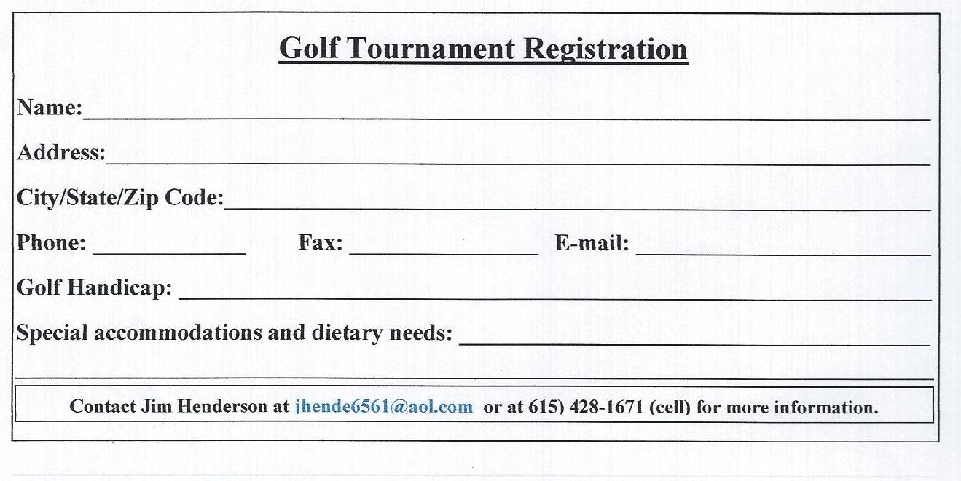
2019 Conference General Information

ACCOMMODATIONS
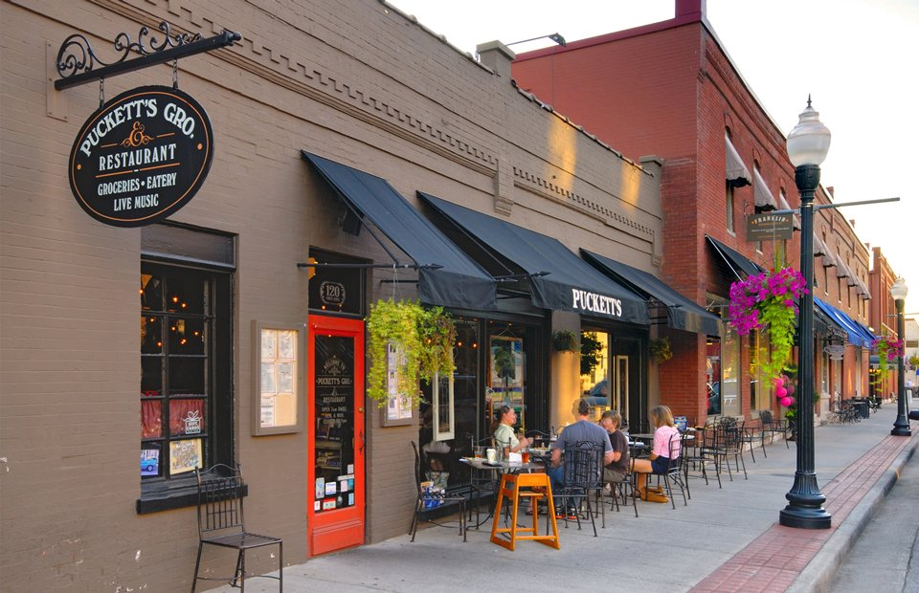
The conference will be held at the Sheraton Downtown Hotel in Memphis, Tennessee. The rate is $139.00 per night. Reservations should be made by April 2nd, 2019 to get the conference rate. In order to best serve our attendees, you can make your reservations by calling the hotel directly or on-line.

Telephone: 901/527-7300
On-line:

HOTEL SHIPPING ADDRESS:
Sheraton Downtown Hotel
250 N. Main Street
Memphis, TN 38103

SPECIAL ACCOMMODATIONS
TPMA will seek to accommodate all persons with disabilities. If you require such special accommodations, please contact Richard Stokes, Executive Director at (615)532-4956

For More Information
Steve Wilensky, Exhibit and Sponsor Chair at (901)751-7550; or Richard Stokes, Executive Director at (615)532-4956.

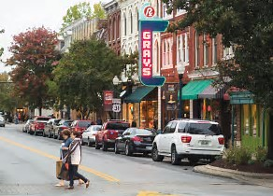
Send forms to-ATTN: Tanya Wilson
tanya.wilson@franklinmarriott.com
Please Return At Least 7 Days Prior to Set Up Date

Officers: | Tennessee Chapter Officers and Board  Members
President  Felecia Boyd  City of Memphis | President-Elect  Cheryl Lewis Smith  City of LaVergne | Immediate Past President  Peter Voss  City of Hendersonville
Treasurer  Paula Taylor  Knox County Sheriff’s Office  Merit System | Secretary  Ora Applewhite  Shelby County Government

Board of Directors:
Kristie Ward  City of Sevierville  George DeCroes  City of Kingsport | Rebecca Hunter  TN Department of HR  Stephen Wilensky  City of Germantown  Alicia Jones  City of Memphis | Richard Stokes  Executive Director  UT-MTAS

TPMA
P.O. Box 190485
Nashville, TN 37219-9998

